1. Parallel 2-bits adder

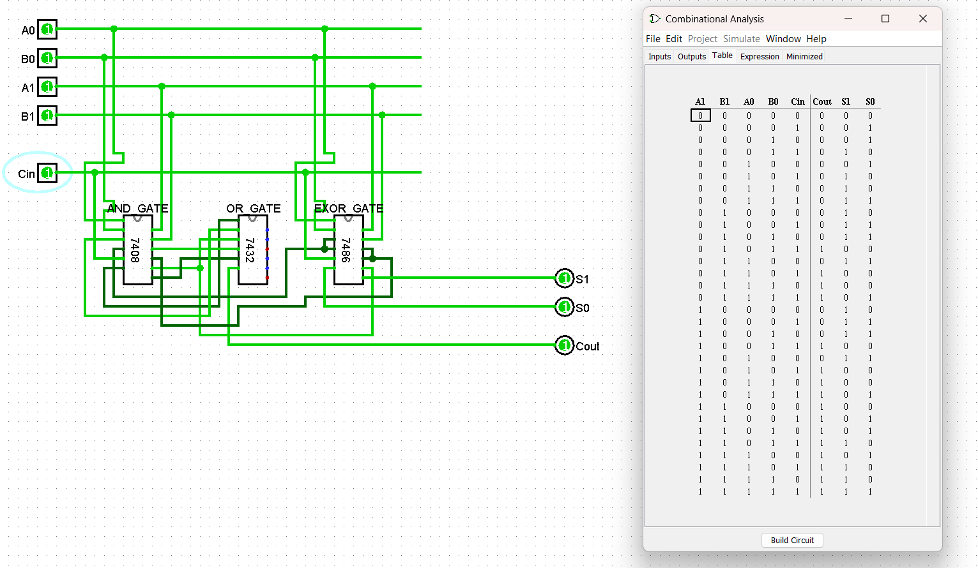

1. 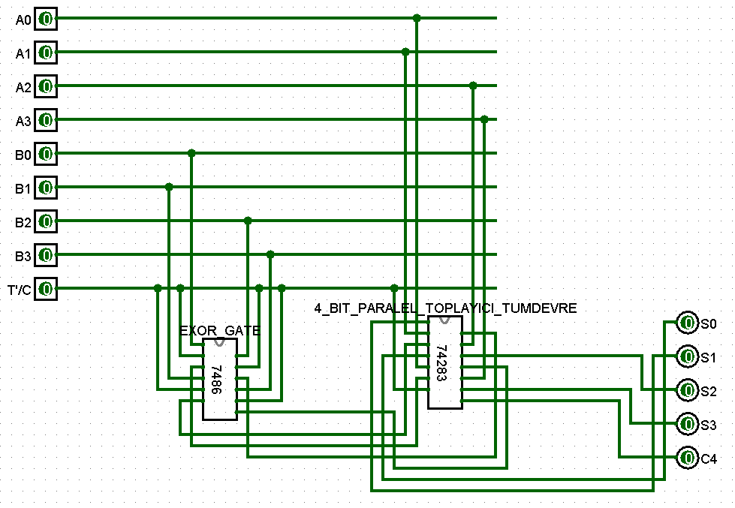Adder/Substractor Circuit

|  |  |  |  |  |  |  |
| --- | --- | --- | --- | --- | --- | --- |
| **T/Ç** | **A** | **B** | **A3A2A1A0** | **B3B2B1B0** | **C4** | **S3S2S1S0** |
| **0** | **8** | **7** | 1000 | 0111 | 0 | 1111 |
| **0** | **11** | **12** | 1011 | 1100 | 1 | 0111 |
| **0** | **3** | **4** | 0011 | 0100 | 0 | 0111 |
| **1** | **1** | **5** | 0001 | 0101 | 0 | 1100 |
| **1** | **6** | **6** | 0110 | 0110 | 1 | 0000 |
| **1** | **14** | **9** | 1110 | 1001 | 1 | 0101 |

1. 4-bit comparator

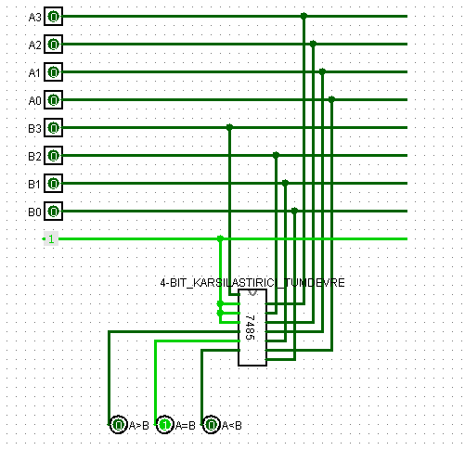

|  |  |  |  |  |  |  |
| --- | --- | --- | --- | --- | --- | --- |
| **A** | **B** | **A3A2A1A0** | **B3B2B1B0** | **A=B** | **A>B** | **A<B** |
| **8** | **3** | 1000 | 0011 | 0 | 1 | 0 |
| **4** | **4** | 0100 | 0100 | 1 | 0 | 0 |
| **12** | **15** | 1100 | 1111 | 0 | 0 | 1 |
| **2** | **13** | 0010 | 1101 | 0 | 0 | 1 |
| **11** | **11** | 1011 | 1011 | 1 | 0 | 0 |
| **10** | **0** | 1010 | 0000 | 0 | 1 | 0 |